**Log Tower(Log Visualization For Analysis)**



**Computer Engineering - Senior Project Report**

**Advisor:** Tuğba Süzek

**Group Members :** Deniz Seçmen

**Date:** 24/06/2022

**Log Tower(Log Visualization For Analysis)**

Deniz Seçmen

Computer Engineer

Muğla Sıtkı Koçman University

26/06/2022

**Summary:**

Log files are the primary data source for network observability. A **log file** is a computer-generated data file that contains information about usage patterns, activities, and operations within an operating system, application, server, or another device [1]. Log files are important for analyzing system errors, upgrades, or errors. And many programs exist in the market that converts logs to graph and charts for better analysis. However, most of them are not free and you must pay for using them. In this project, I developed a desktop native application for analyzing logs using different types of charts. For the implementation of the main project, I used electron and javascript. And I used MySQL for storing the logs in the database and I use chart.js for converting log files to charts and graphs.

**Table of Contents**

1. Introduction 3

2. Methods 3

1. Market Research
2. Development of front-end and file communication 3
3. Development of database connection
4. Development of charts for log files 4

3. Conclusion 5

4. References 5

# Introduction

Log files are important for system administrators. With log files administrators can detect error or notifications. Also, it is possible to record each login to system for using to detect possible cyber-attacks. And visulation can be used making logs more human readable. So it log visulation is very important at many aspects.

# Methods

At first implementation, I started with market research. I research all the programs in the market and make a comparison between them. After the research, I made a comparison between them. After comparison, I start to implement programming with the design of the front-end of the application. Then I made configured communication between files inside the program. After that, I configure the MYSQL communication for storage data and types. In end, I added charts to the program for better analysis.

## 

## Market Research

In the market, there are many log analysis programs. However, most of the log analysis tools are not free. And their values changes based on storage capacity, abilities, and backup limits. There are very few ones free however lack technical support or detailed analysis. After the market research, I implement research about types of logs. And I learned the types of log formats which are used most.

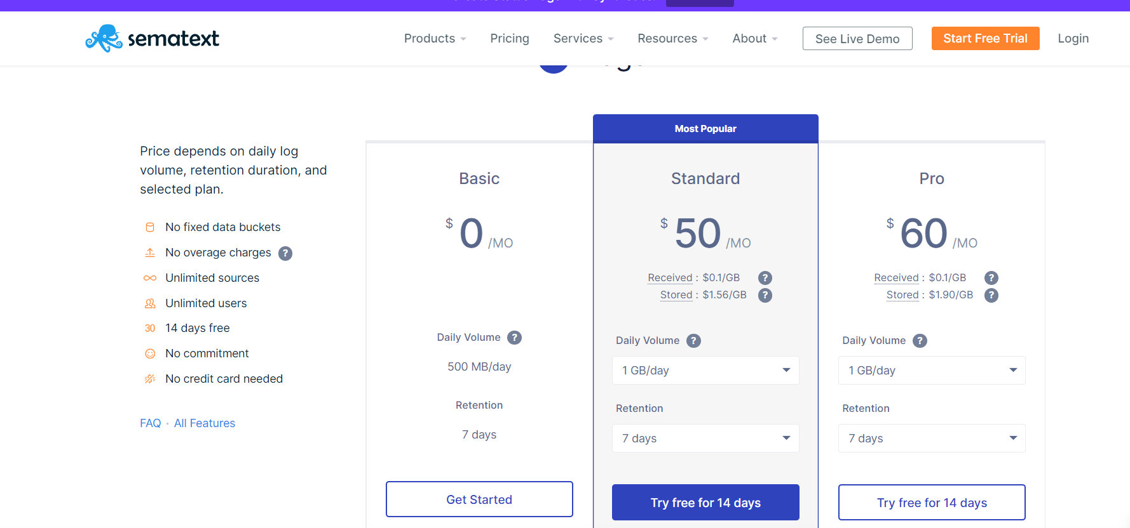

[2] price policy of Sematext log file analyser.

## Development of front-end and file communication

For building the main part of application I used electron. Electron is framework that give ability to make native desktop app using HTML, CSS and javascript [2].I choose electron because ability to desing easily like making a web API.At first, I made main index.html file and main.js file for building the basic part of the program. Then I create an iframe tag inside of the main for connection to other pages to the main program. After that, I design a vertical navbar for main.html.I used JQUERY for implementing slide animations. The rest of the program is made by CSS and HTML5. I used the window communication protocol for communication between front-end files. And I use the IPC protocol for connection from the front end to the backend.

1. **Development of Database Connection**

I used MYSQL for storage the files and paths. I used path column as primary key at database. And I create for column at database(path,type,raw_data,parsed).After creation of the database. After creation database, I called database from main backend each insertion, removing and renewing table events.

1. **Development of graphs inside the project**

I used chart.js to make a pie chart for analyzing the log files that choose by the user. At first, I write a function for parsing the log file of each attribute based on its log format that was declared by the user. After that, I count each attribute and plot the pie chart of these counts. In the end, I assign a color to each attribute.

# Results

As the result, I developed an application that violated and parsed selected files. While developing I use an electron framework with HTML 5, CSS 3.0, Javascript, and bootstrap. With these application errors and notifications can easily seen by system administrators

# Conclusion

In this project, I developed a program in which you can see and analyze log files well using chars inside the application. And it will be helpful for work in the IT sector. And can detect errors and notifications well.

# References

[1] <https://www.sumologic.com/glossary/log-file/>

[2] https://sematext.com/pricing/#logsene